**Team Phoenix**

* Barath Kumar J
* Harish TS
* Hariharan A
* Advaith Sankar S

# Technology Stack: **Cloud Application Development**

# Problem Statement: **HealthConnect: Streamlined Doctors Appointment and Health Record Management**

**Problem Statement:**

Inefficient and disjointed management of doctors' appointments and health records has become a significant challenge in the healthcare industry. Many patients struggle with the process of scheduling appointments, accessing their health records, and coordinating care between multiple healthcare providers. This fragmented system leads to delays, miscommunication, and ultimately affects the quality of patient care.

"HealthConnect" is a comprehensive Cloud application designed to revolutionize the way you manage your doctors' appointments and health records. With a user-friendly interface and powerful features, our app aims to streamline healthcare management, ensuring convenient access to medical professionals and organized health records at your fingertips.

**Expected Solutions:**

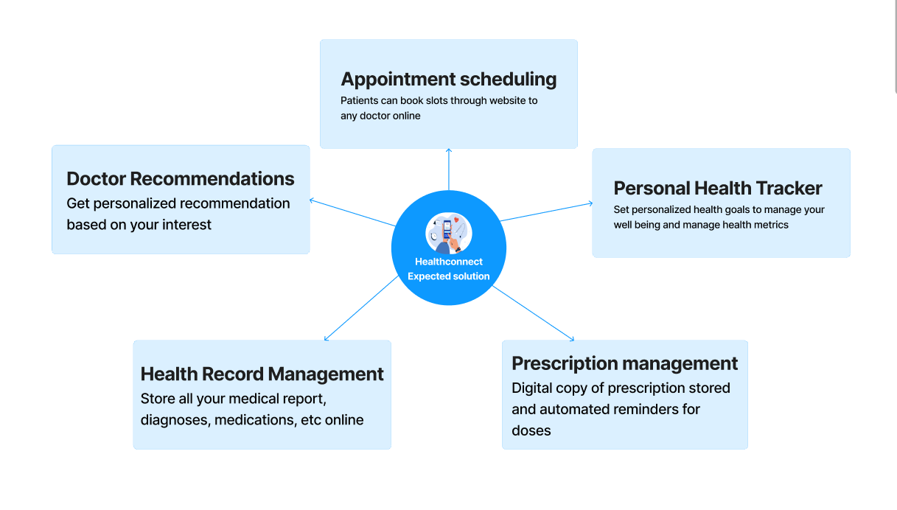

The Expected solution should have the following key features:

Appointment Scheduling: Effortlessly book appointments with doctors, specialists, and healthcare facilities directly from the app. Check real-time availability, select suitable time slots, and receive instant confirmation for your appointments.

Doctor Recommendations: Discover healthcare providers based on your location, specialty preferences, and patient reviews. Access detailed profiles that include qualifications, experience, areas of expertise, and other relevant information to make informed decisions.

Health Record Management: Digitize and store your medical records securely in one place. Easily manage and access your health history, including diagnoses, medications, allergies, lab results, and immunizations. Maintain a comprehensive overview of your health journey. User will be able to control doctor's access to their profiles

Prescription Management: Capture and store digital copies of your prescriptions, making it easy to manage and refill medications. Receive automated reminders for medication doses, ensuring you never miss a dose.

Personal Health Tracker: Monitor and track your health metrics, such as blood pressure, weight, glucose levels, and more. Visualize trends and set personalized health goals to proactively manage your well-being.

HealthConnect Empowerment Pro – Documentation

**Idea Overview:**

HealthConnect Empowerment Pro is an innovative healthcare management platform that revolutionizes how users engage with their health. It combines seamless appointment scheduling, doctor recommendations, health record management, prescription reminders, personal health tracking, online consultation, a virtual health community with a podcast forum, a wellness rewards program, charitable partnerships with NGOs, inspiring doctor-granted achievement badges, image recognition for medical images, video conferencing, and the Symptom Checker Chatbot. This comprehensive solution empowers users to take control of their health, fosters a supportive virtual community, and promotes social impact through charitable partnerships with NGOs.

Users can also explore and purchase healthcare products from the integrated Healthcart platform. The Healthcart feature allows users to utilize reward points earned through engagement for discounts and product purchases. Furthermore, the platform introduces a unique dual point system where users earn both "Experience Points" and "Reward Points." Experience Points determine the user's tier, unlocking exclusive privileges within the platform.

**Hosted website link :** [**http://13.235.114.236:3000**](http://13.235.114.236:3000/)

# Explanation Video Drive link :

If you need to see the prototype explanation of how it looks , a brief of how it has been given in the following drive link . However it is advised to read and then look at the video for a complete visualization with all the backend explained in doc and front end being in video , a full stack visualization will be experienced.

[Click to view Prototype video](https://drive.google.com/file/d/1X_lwGnd4UjdkbANeWqy8S_ZU337wHBq4/view?usp=sharing)

**##Key Features:**

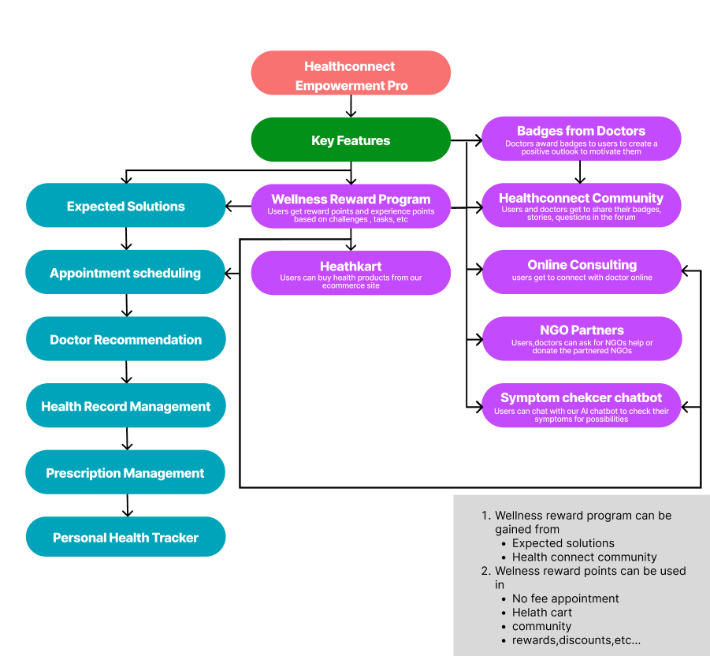

1. **Appointment Scheduling:**

- Effortlessly book appointments with doctors, specialists, and healthcare facilities directly from the app.

- Check real-time availability, select suitable time slots, and receive instant confirmation for appointments.

- Earn reward points for every confirmed appointment booked through the app.

2. **\*\*Doctor Recommendations:\*\***

- Discover healthcare providers based on location, specialty preferences, and patient reviews.

- Access detailed profiles with qualifications, experience, areas of expertise, and patient reviews.

- Earn reward points for reviewing doctors and specialists after appointments.

3. **\*\*Health Record Management:\*\***

- Digitize and store medical records securely in one place.

- Manage and access health history, diagnoses, medications, allergies, lab results, and immunizations.

- Earn reward points for regularly updating and maintaining health records.

4. **\*\*Prescription Management:\*\***

- Capture and store digital copies of prescriptions for easy management and refills.

- Receive automated reminders for medication doses to ensure medication adherence.

- Earn reward points for consistently adhering to medication schedules and recording medications in the app.

5. **\*\*Personal Health Tracker:\*\***

- Monitor and track health metrics such as blood pressure, weight, glucose levels, etc.

- Visualize trends and set personalized health goals for proactive management.

- Earn reward points for achieving health milestones and meeting health goals.

6. **Virtual Health Community:**

- Users can share health journeys, achievements, and stories within the community.

- Foster support, motivation, and health education among members.

- Healthcare professionals participate, offering insights and advice.

- Introducing the Podcast Forum: Engage with health-related podcasts, discussions, and expert interviews within the community.

- Earn reward points for active participation in the community, contributing valuable insights, and helping others.

7. **\*\*Wellness Rewards Program:\*\***

- Incentivize users to engage in health challenges and complete wellness goals.

- Earn reward points for activities, redeemable for discounts, products, or charitable donations.

- Introducing a unique dual point system: Users will earn both "Experience Points" and "Reward Points." Experience Points determine the user's tier, unlocking exclusive privileges.

8. **\*\*NGOs partner Program:\*\***

- Partner with NGOs providing free healthcare services to underserved communities.

- Users can donate earned reward points to support essential healthcare services.

- Earn experience points based on the number of reward points donated to support social impact initiatives.

9. **\*\*Healthcart:\*\***

- Users can explore and purchase healthcare products from the integrated Healthcart platform.

- Reward points earned through engagement can be utilized for discounts and product purchases on Healthcart.

- Earn reward points for purchases made through Healthcart and redeeming rewards.

10.**Video Conferencing:**

* + Seamlessly conduct video conferences with healthcare professionals for remote consultations and follow-ups.
  + Schedule virtual appointments and receive personalized medical advice from the comfort of your home.
  + Earn reward points for participating in video conferencing sessions and engaging in virtual consultations.

11.**Symptom Checker Chatbot:**

Introducing an interactive Symptom Checker Chatbot, powered by AI, that guides users through a personalized assessment of their health symptoms. The chatbot provides instant insights into potential health conditions, recommends appropriate actions, and encourages users to seek timely medical advice. Earn reward points for using the Symptom Checker Chatbot and engaging in proactive health management.

**## Impact and Benefits:**

* **Primary Goal:**

The primary goal of HealthConnect Empowerment Pro is to create an all-encompassing healthcare management platform that streamlines appointment scheduling, optimizes doctor recommendations, promotes proactive health tracking, and fosters a supportive virtual community. By incentivizing wellness goals and charitable donations through the rewards program, the platform aims to empower users to take control of their health while making a positive impact on underserved communities.

- Doctor-granted badges motivate users to achieve their health goals and celebrate their resilience.

- The virtual health community becomes a source of encouragement and support, with users sharing inspiring stories and achievements.

- Users feel recognized for their efforts in managing their health, leading to increased engagement and empowerment.

* **Social Impact Initiatives:**

* Host virtual fundraising campaigns to contribute points to specific healthcare projects run by partner NGOs.
* Advocate for health equity and equal access to healthcare services
* **Doctor-Granted Achievement Badges:**

- Doctors can recognize users' significant health milestones, surgeries, or effective disease management by granting achievement badges.

- Each badge represents a specific accomplishment and serves as a source of motivation for users to stay committed to their health goals.

- Users can proudly showcase their badges in the virtual health community, sharing inspiring stories and fostering a supportive environment.

* **Business Goals & Benefits:**

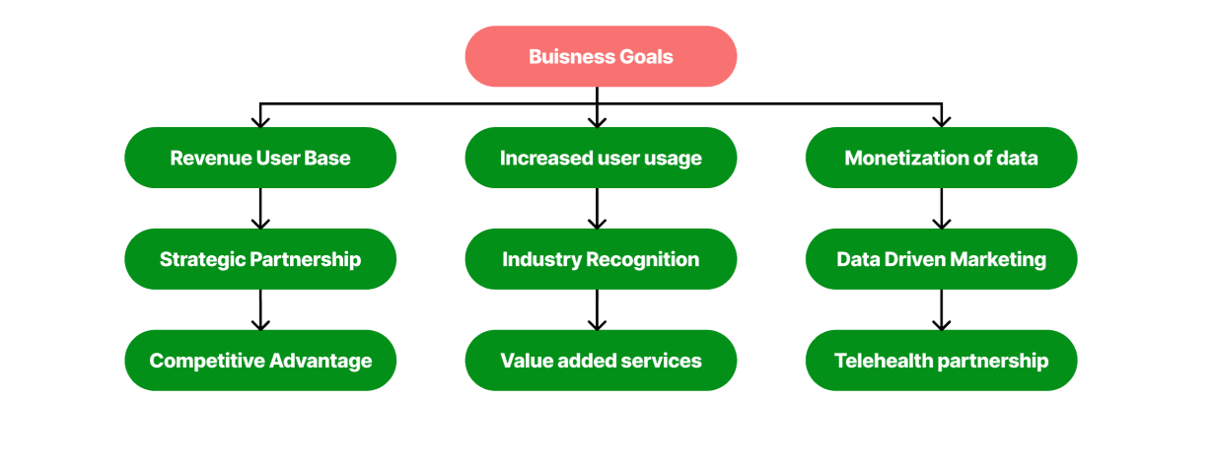

Increased User Base: Attract and retain more users with a comprehensive and engaging healthcare management platform, leading to potential revenue growth.

Revenue Generation: Integrate Healthcart for healthcare product sales, incentivizing users to spend more on the platform.

Monetization of Data: Utilize gathered user data for insights, selling anonymized data to healthcare providers and researchers.

Strategic Partnerships: Social impact initiatives attract potential sponsors and partners, leading to financial support and increased brand visibility.

Premium Services: Offer subscription-based premium services like health programs and personalized coaching for additional revenue streams.

Industry Recognition: Innovative features and user-centric design establish the company as a leader in healthcare technology, improving brand recognition.

Data-Driven Marketing: Utilize user data for targeted marketing and advertising, improving customer acquisition and retention.

Telehealth Partnerships: Video conferencing opens opportunities for partnerships with healthcare providers interested in telehealth services.

Value-Added Services: Strategically upsell services like health coaching and personalized health plans, increasing revenue per user.

Competitive Advantage: Comprehensive and socially impactful platform gains a competitive edge, attracting a larger market share.

By achieving these business goals, the HealthConnect Empowerment Pro platform becomes a lucrative and influential solution, benefiting the company financially and strategically in the healthcare technology industry.

**## Other Key features Goals:**

i)making appointment scheduling effective with fcfs and sjf and priority scheduling to reduce idle time of doctor when a slot is cancelled or finished than the expected time.

* For example for doctor X all slots are filled or the desired slot is not free for the user we add a waiting lobby system where the user enters their desired time or if wants to wait for a doctor.
* If a slot is cancelled the users will be sent a notif who opted to wait
* If finished faster those patients who are available in hospital may pushed up or send a prior notif regarding the slot may be free based and wants to upgrade.IF no one wants to upgrade a notif will be sent to the waiting lobby people and if nearby they can take the slot.
* Have an extra slot based on the interest of doctor for senior citizens for priority basis and not fight for slots with younger faster gen who might win in an fcfs fashion

ii)Rating system more diverse considering multiple factors,

* A general 5 star rating is not enough to determine a mbbs doctor.
* For example parameter like friendly conversation maker might not be the best doctor for a person who is running on tight schedules whereas ones not might find a liking which makes the general rating not accurate.

iii) a doctor based site and a patient based site,

* For efficient appointment scheduling where doctor can tell this slot has done faster or patient not showed up and open for waiting list.
* For video consulting and for him to add a slot by himself for that patient when required

iv)security for medical record management,

* Previous doctors who treated a patient can have access to their profiles for a stipulated amount of time and a doctor who is treating him right now can have full access and for the rest it is private.

v)Reminder for medicine with yes/no feature when taken and and a interactive ui/ux to show that .If you need more medicines redirect to sites which have the available medicines you need.

vi)making personal health tracker more efficient with connecting to IOT edge/smart devices and syncing at end of every day and based on the date changing goals and diets.

vii)Add online video conferencing for those far away. Add features for doctor for himself to book for the patient If needed. Add lobby

**## Platform:**

A responsive website for desktop and mobile may be developed

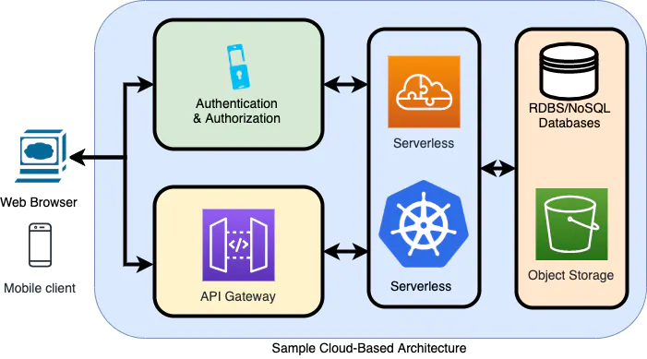

**## Resources/Skillsets Required:**

Expected:

Python, IBM Cloud, Redhat openshift, IBM cloud object storage, Docker, Kubernetes

Extra :

Reactjs, Firebase, NoSQL.

# Explanation with Prototype:

1)

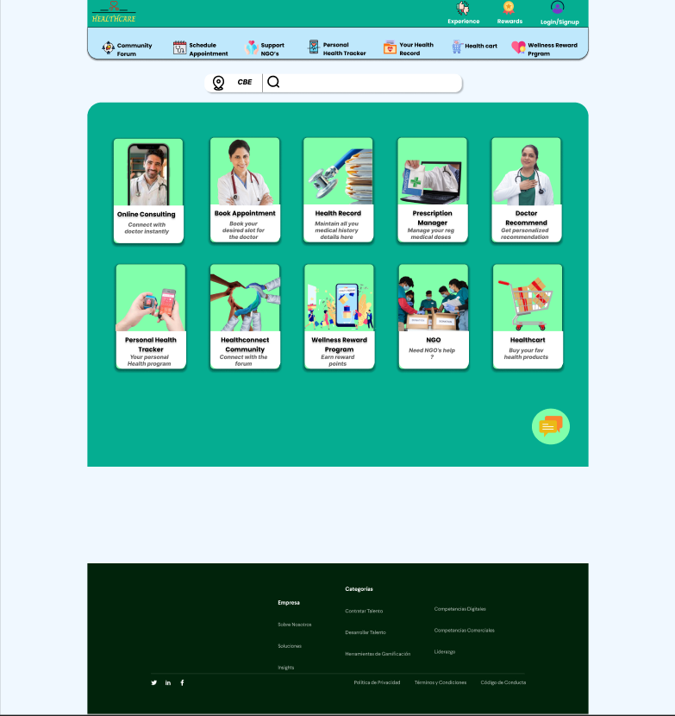

This is the landing page when the user enters our website where he can see all the available features as shown

2)

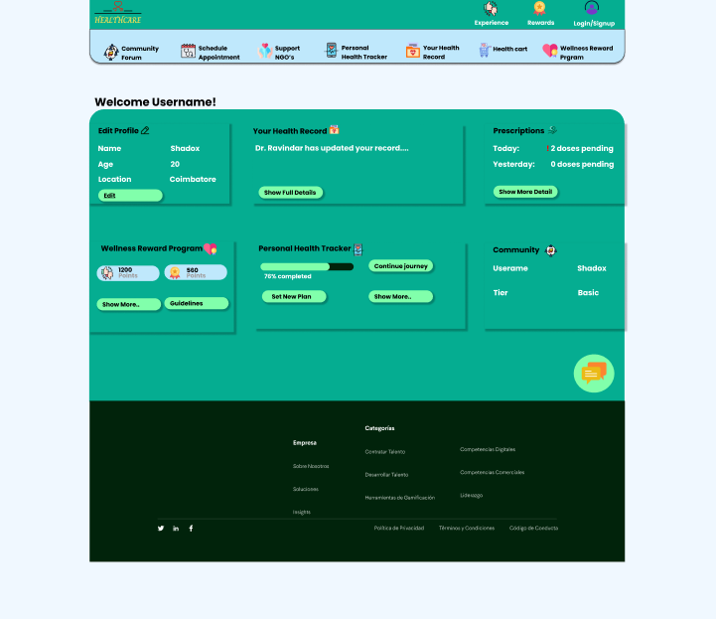

This is the user dashboard where he can see the details of the user.

3)

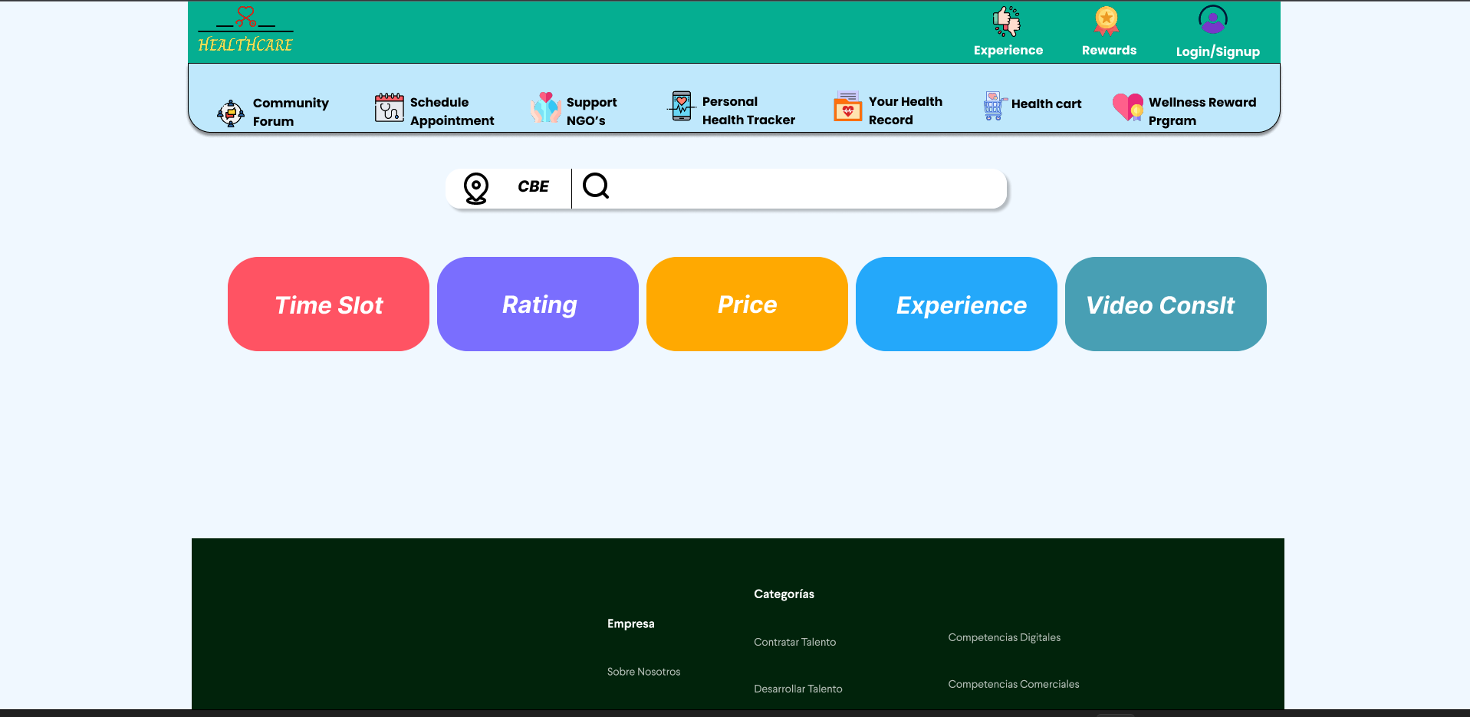

When you click doctor recommendation a page appears where you may or may not fill these parameters so it will you give you a set of recommendd doctors in the next step

4)

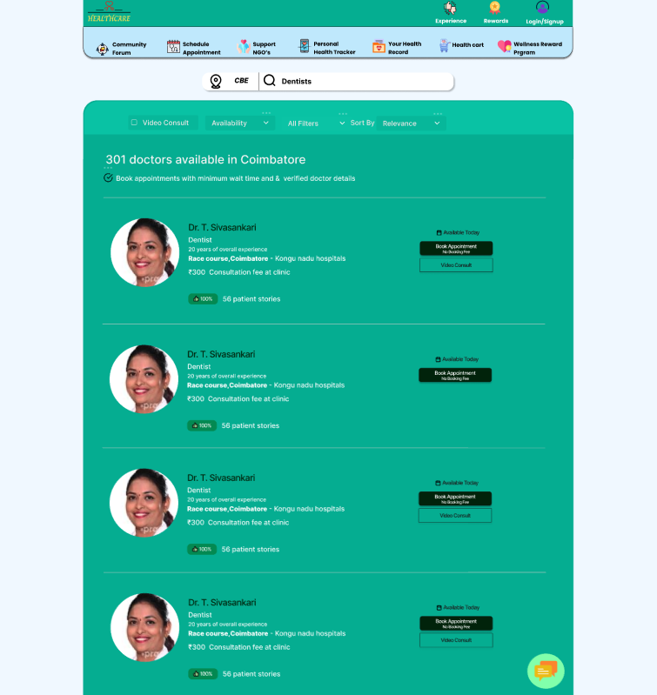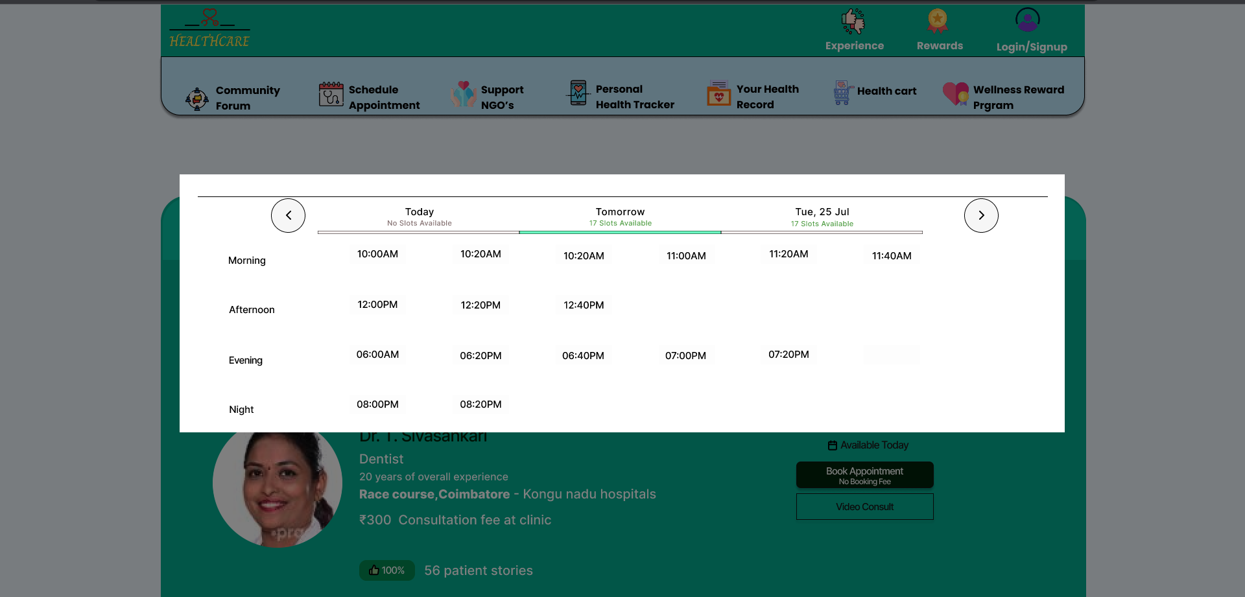

When appointment scheduling is clicked after you give your requirments a recommended set of doctors are visible and when you click book appointment a pop up like above appears to book.

5)

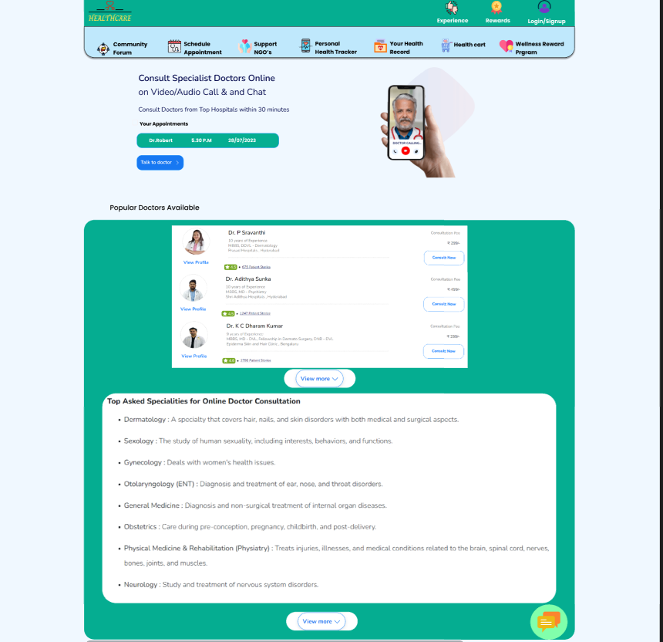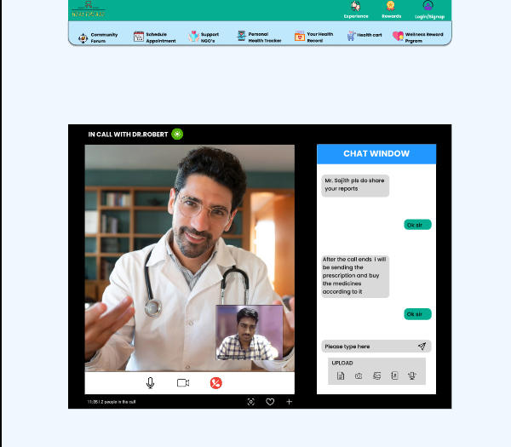

When you click consult online above 2 pages appear where you will again be asked for a slot and once you confirm you may talk when you click the talk to doctor option where your appointment details will be visible.

6)

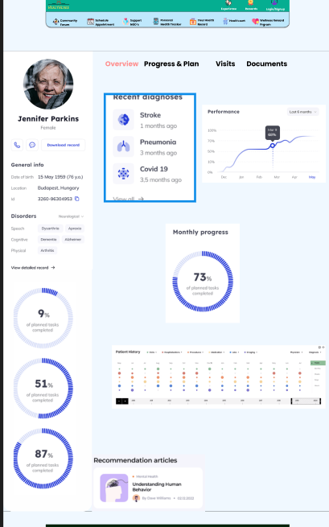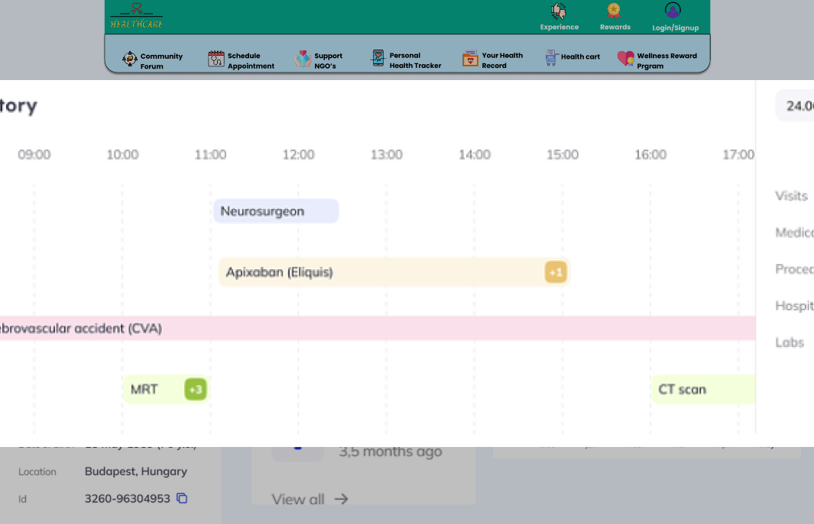

When you click your health record where you will see your list of all medical records, diagnoses, lab results , etc

7)

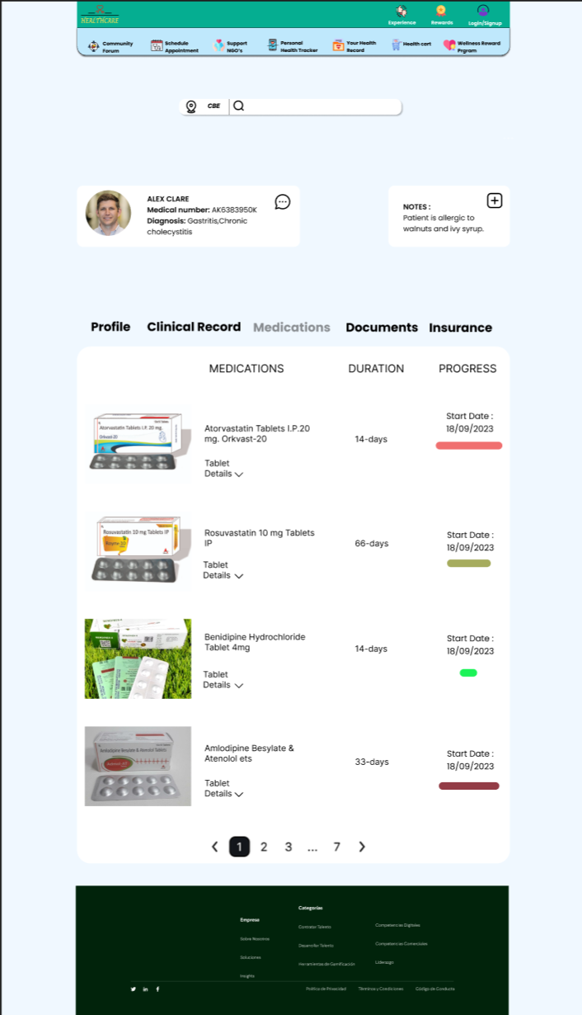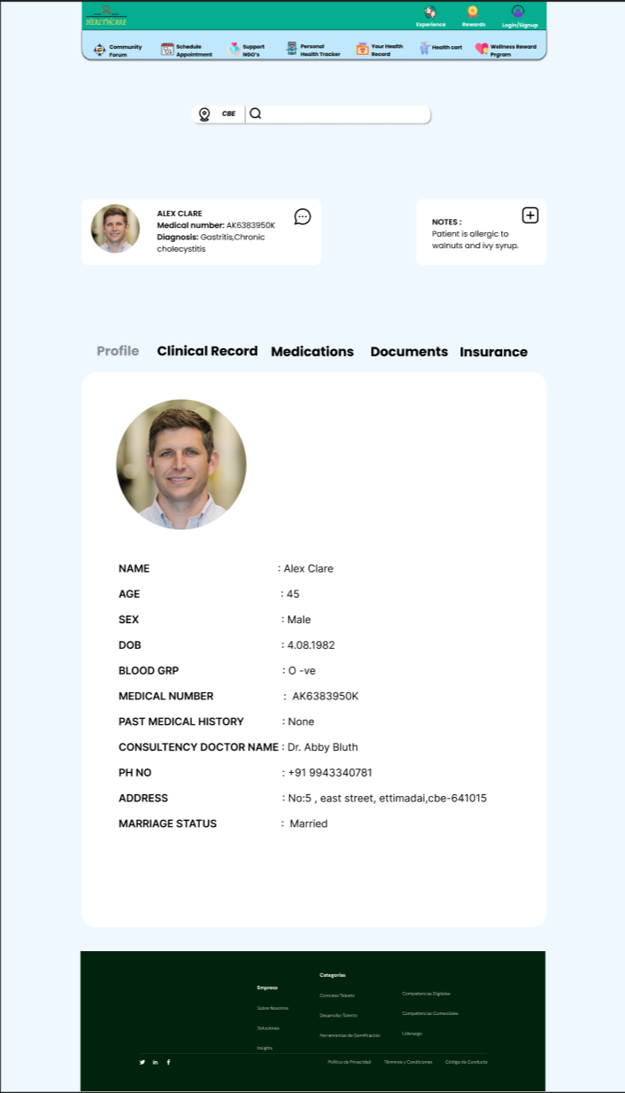

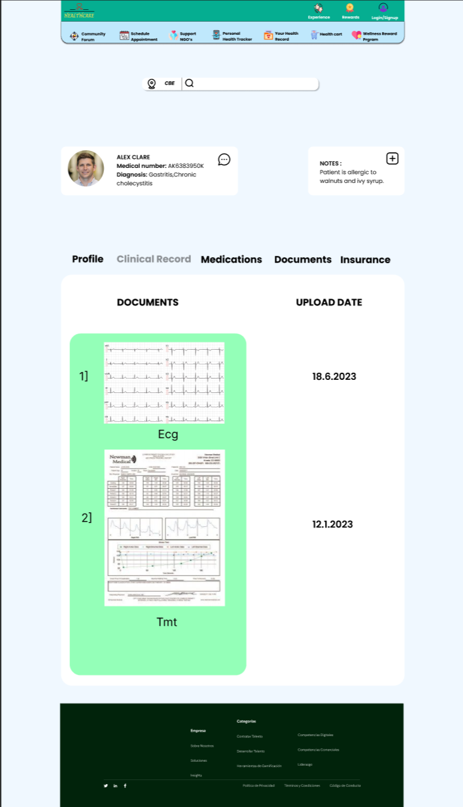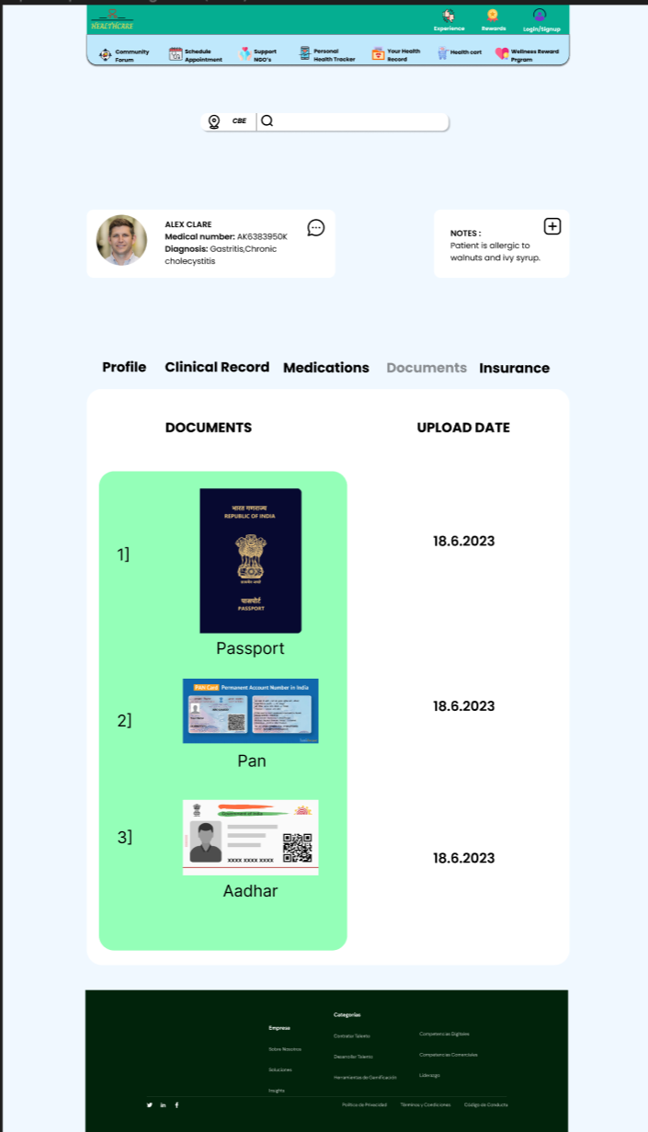

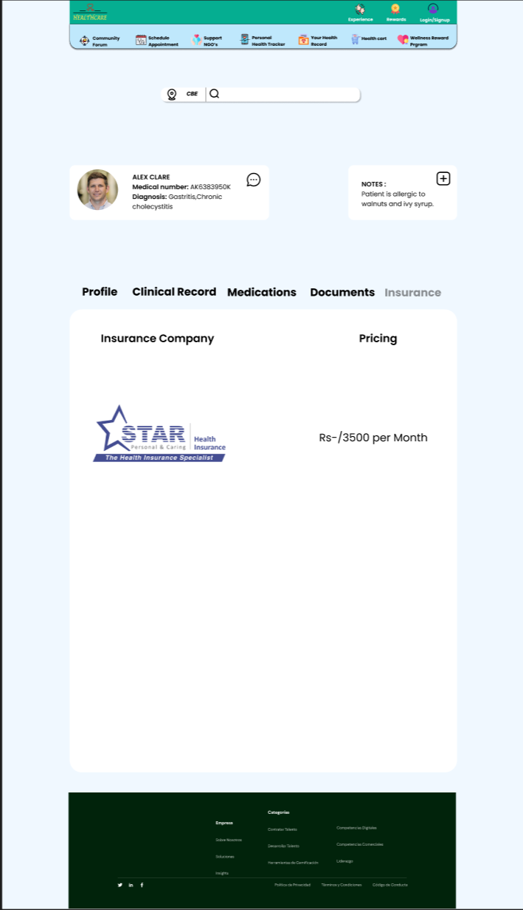

When you avail prescription manager you will see the present medical dose details and its progress and more where you can manage as mentioned you can upload your prescription too when you click next page number. It also gives a caution message for few medicines which is represented in red bar below the start date. If the medicines are full it shown in green bar. In prescription manager you can also view your profile which contains your name, sex, age, address, consulting doctor etc... in this we can also view the uploaded clinic records from the hospital, and we can also upload the docs from our device using add symbol. Mainly this prescription manager maintains the medical insurance company info which you have bought and the price per month. Finally, this also contains the essential documents like Aadhar, Passport, Pan so need not to always carry these items with you and there is an option upload more documents also

8) 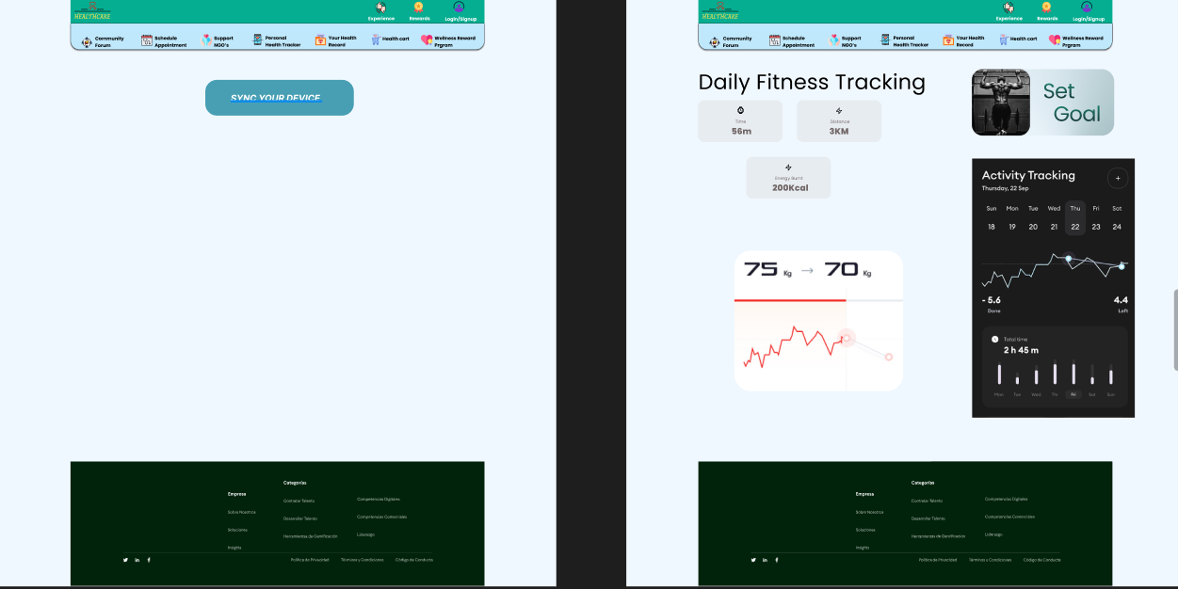

when you avail personal tracker you may see a page where you can set goals , diets , and make progress in it and more and you will be asked to sync your fitness device if avalable to check for metrics like heartrate,bp,o2 level etc

9)

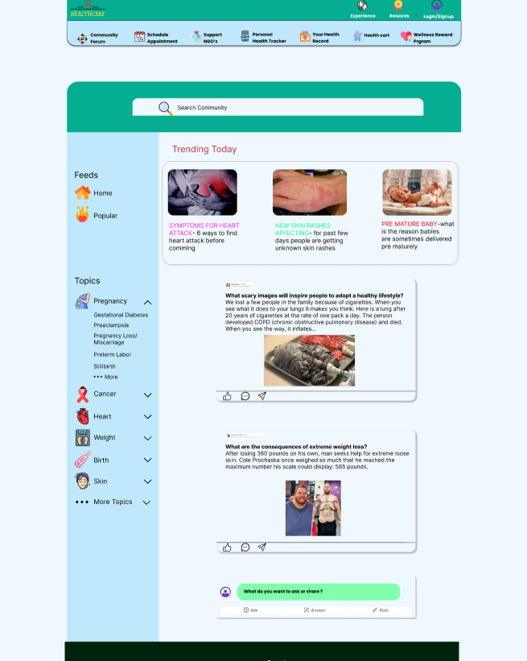

When you click healthconnect community a forum will be shown where all will be discussed including questions, stories , discussions etc.

10)

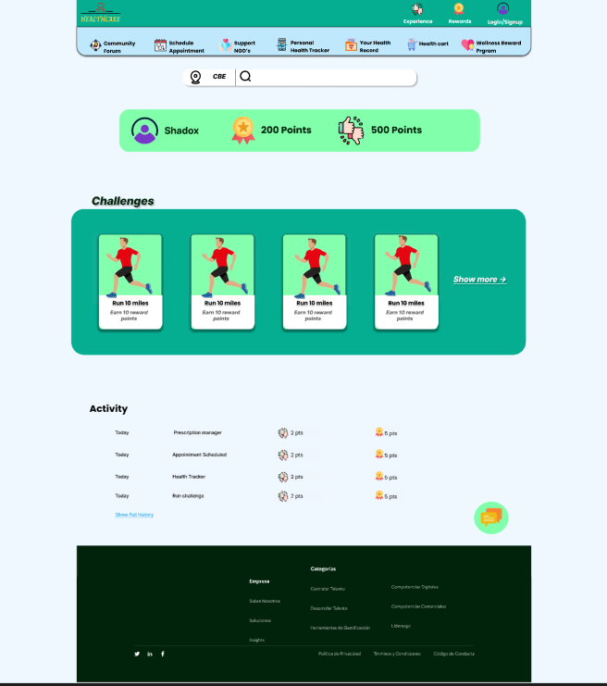

Wellness reward program is the ultimate feature to increase user usage by giving challenges and more you can view that 2 types of points can be gained.Not only from challenges but from all features like appointment scheduling , health tracker you can gain through our algo.

11)

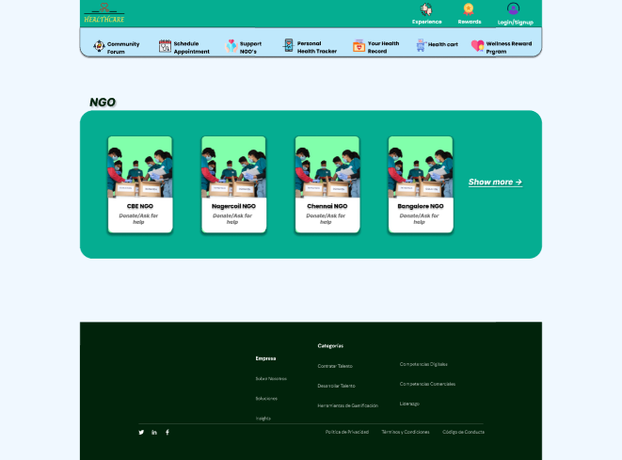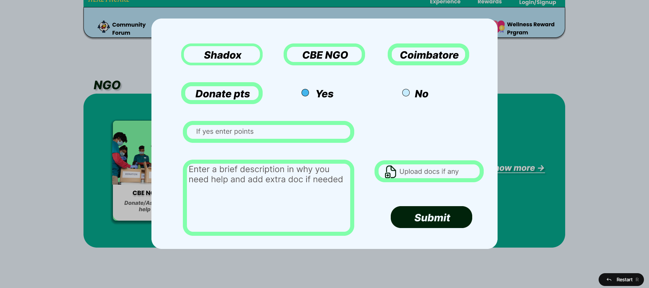

With NGOs page we can view the list and which one you prefer you can fill the pop out form that is shown

12)

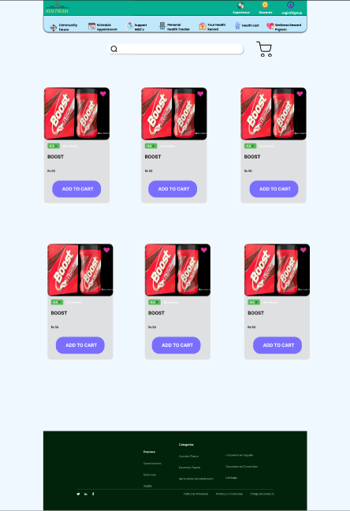

With Healthcart page you can shop the items based on your interest.

13)



13)symptom checker chatbot available in all pages as a overay pop up will be there to assist you with the symptoms and give a pre examination which uses a api with AI and NLP.

14)

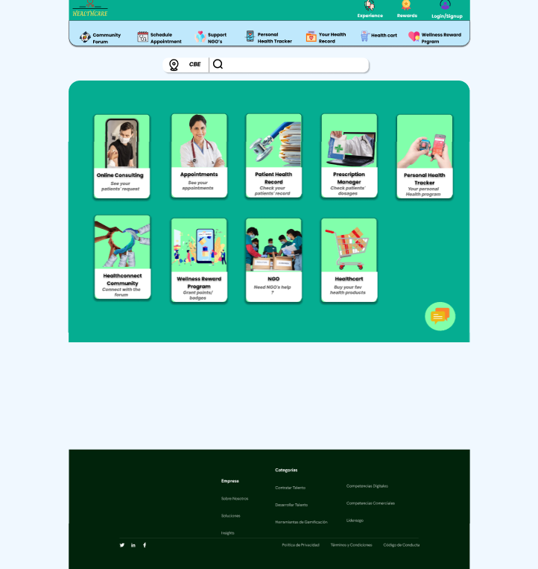

A doctor perspective landing page where the features are altered in his favour to check patient’s appointments, health records, prescriptions, grant points/badges in wellness program ,answer in community etc

15)

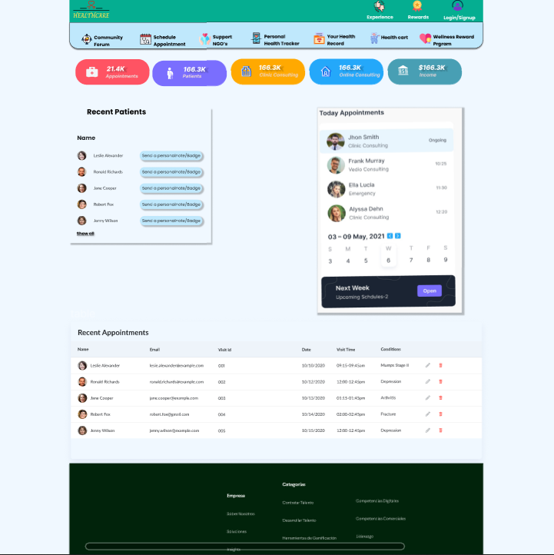

A doctor perspective dashboard where all the fetaures are given in a easy way to view all details as shown above and more.

12)Database tabels:

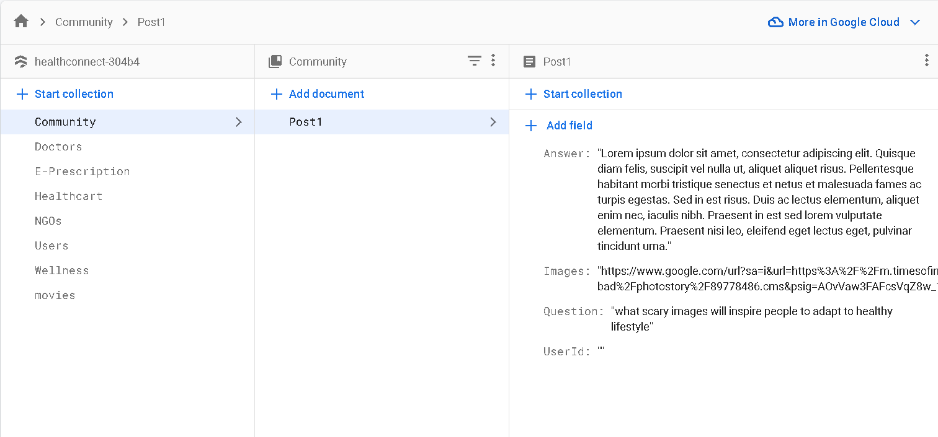

# Explanation Video Drive link :

Has an link to detailed video explanation of prototype and ui prototype link

<https://drive.google.com/file/d/1X_lwGnd4UjdkbANeWqy8S_ZU337wHBq4/view?usp=sharing>

**Estimated Duration:**

The development and testing phase are estimated to take approximately 4 weeks to gather sufficient data and analyze user behaviors, interactions, and feedback.

We plan to develop the backend features as first prioirty and build front end over it as from prototype itself frontend is almost over.

**## Likelihood of Test Success:**

8 out of 10 - The hypothesis is based on identified pain points in the healthcare industry, user feedback, and industry best practices. The addition of new features and enhancements is expected to positively impact user engagement and overall user experience, leading to a higher likelihood of success.

**## Conclusion:**

With its user-centric design, innovative features, and focus on social impact, HealthConnect Empowerment Pro, along with the unique dual point system and Symptom Checker Chatbot, has the potential to revolutionize healthcare management, inspire user engagement, and create a meaningful contribution to individuals and underserved communities. The platform's comprehensive approach to healthcare empowers users to take charge of their well-being while fostering a supportive virtual community for mutual growth and motivation. The addition of video conferencing enhances the platform's capabilities, enabling remote consultations and personalized medical advice from healthcare professionals, further improving user experience and accessibility.